**Experiment Procedure Documentation**

**Introduction**

This document captures the instructions to run the simulation.

**Instructions**

1. To run the experiment, simply run the Bressenhem.html file by clicking on it and the experiment will open in the browser.
2. First set the frame values or continue with the default values keeping in mind that the range of coordinates should not exceed the frame values after setting the frame values now set the coordinates.

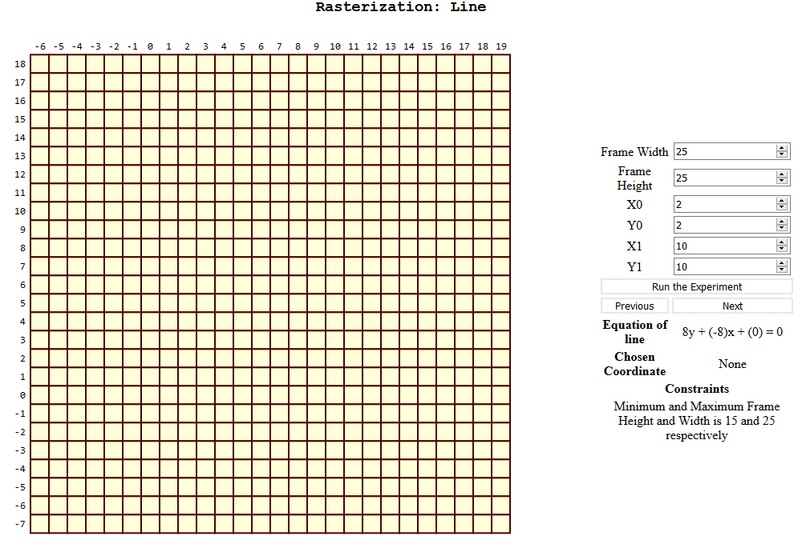

1. To run the experiment of Rasterization of Line, click on the Run the Experiment Button to initialize the value and Line.

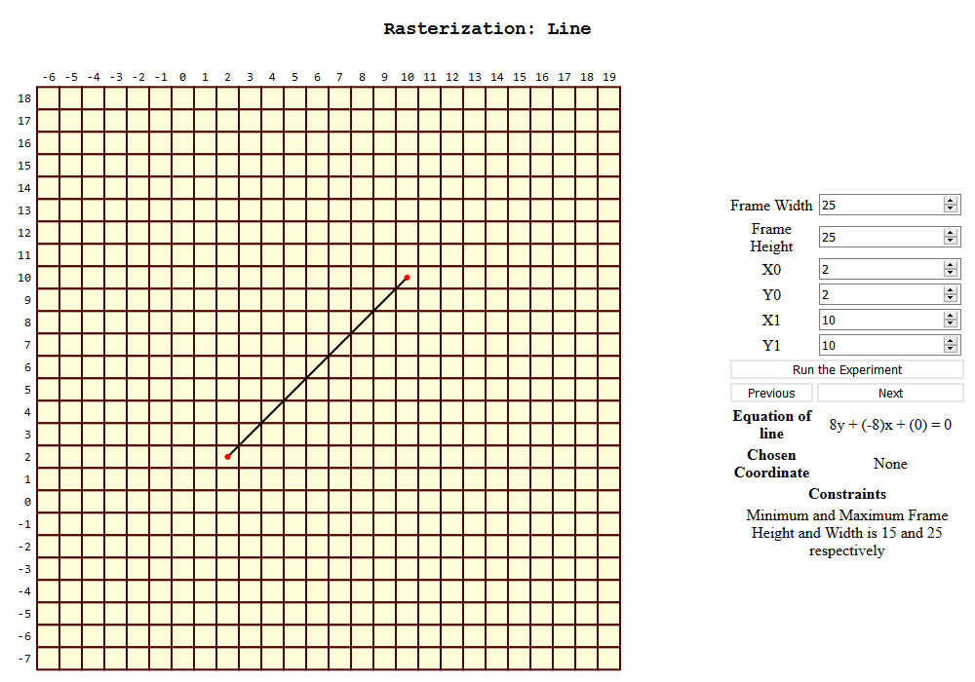

1. Now to start the experiment click on the next button to see the results.

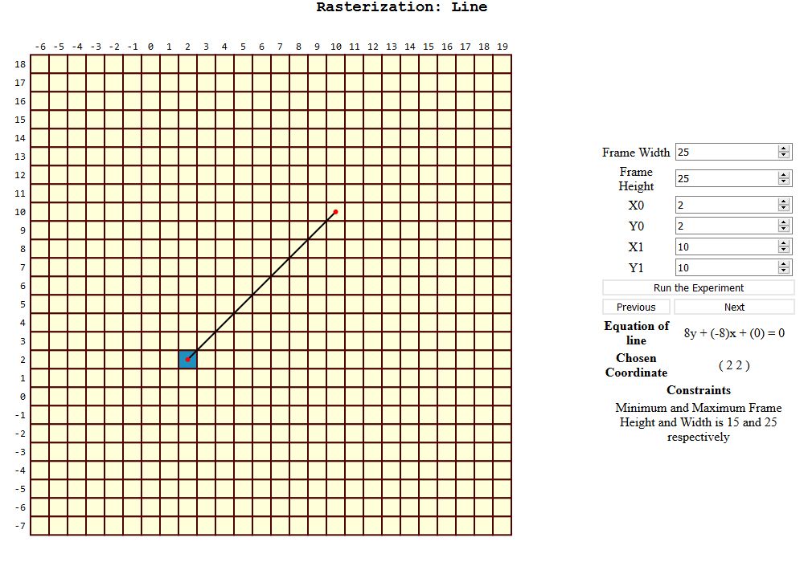

1. Now first coordinate is selected in the same manner continue till the end of line to complete the experiment, you can use previous button as well to cross check some step.

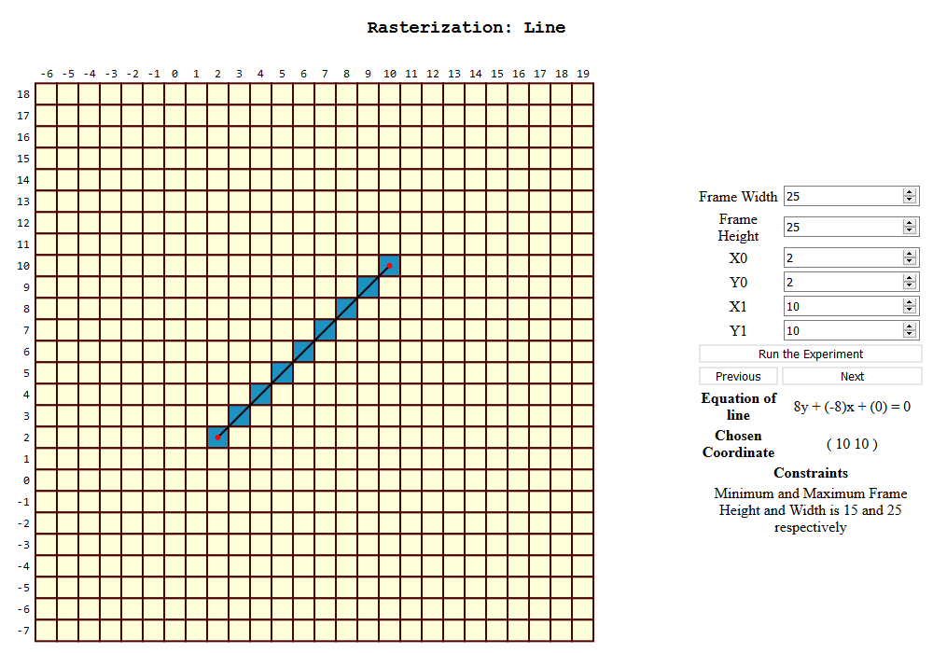

1. Now the experiment is complete you can re-run the experiment by clicking on the Run the Experiment button and start again with the new values.